|  |  |  |  |
| --- | --- | --- | --- |
| |  | | --- | |  | | 77thDevice Research Conference (2019) |  |
|  |

**Variants of Ferroelectric Hafnium Oxide based Nonvolatile Memories** 

T. Mikolajick1,2

1 NaMLab gGmbH, Noethnitzerstrasse 64, 01187 Dresden 2 Institute of Semiconductors and Microsystems, TU Dresden, 01062 Dresden

|  |  |  |
| --- | --- | --- |
| 1 | a t u d r e s d e n | c o m p a n y |

Outline

|  |  |
| --- | --- |
| |  | | --- | | Introduction | |

|  |  |
| --- | --- |
| |  | | --- | | Ferroelectricity in Hafnium Oxide | |

Capacitor based Ferroelectric Random Access Memory

|  |  |
| --- | --- |
| |  | | --- | | Ferroelectric Tunnel Junction Memory | |

|  |  |
| --- | --- |
| Other Applications   |  | | --- | | Ferroelectric Field Effect Transistor Memory | |

|  |  |  |  |
| --- | --- | --- | --- |
| |  | | --- | | Negative Capacitance FET | | a t u d r e s d e n | c o m p a n y |

Outline

|  |  |
| --- | --- |
| |  | | --- | | Introduction | |

|  |  |
| --- | --- |
| |  | | --- | | Ferroelectricity in Hafnium Oxide | |

Capacitor based Ferroelectric Random Access Memory

|  |  |
| --- | --- |
| |  | | --- | | Ferroelectric Tunnel Junction Memory | |

|  |
| --- |
| Other Applications  Ferroelectric Field Effect Transistor Memory |

|  |  |  |  |
| --- | --- | --- | --- |
| |  | | --- | | Negative Capacitance FET | | a t u d r e s d e n | c o m p a n y |

Ferroelectricity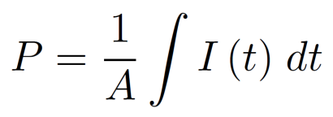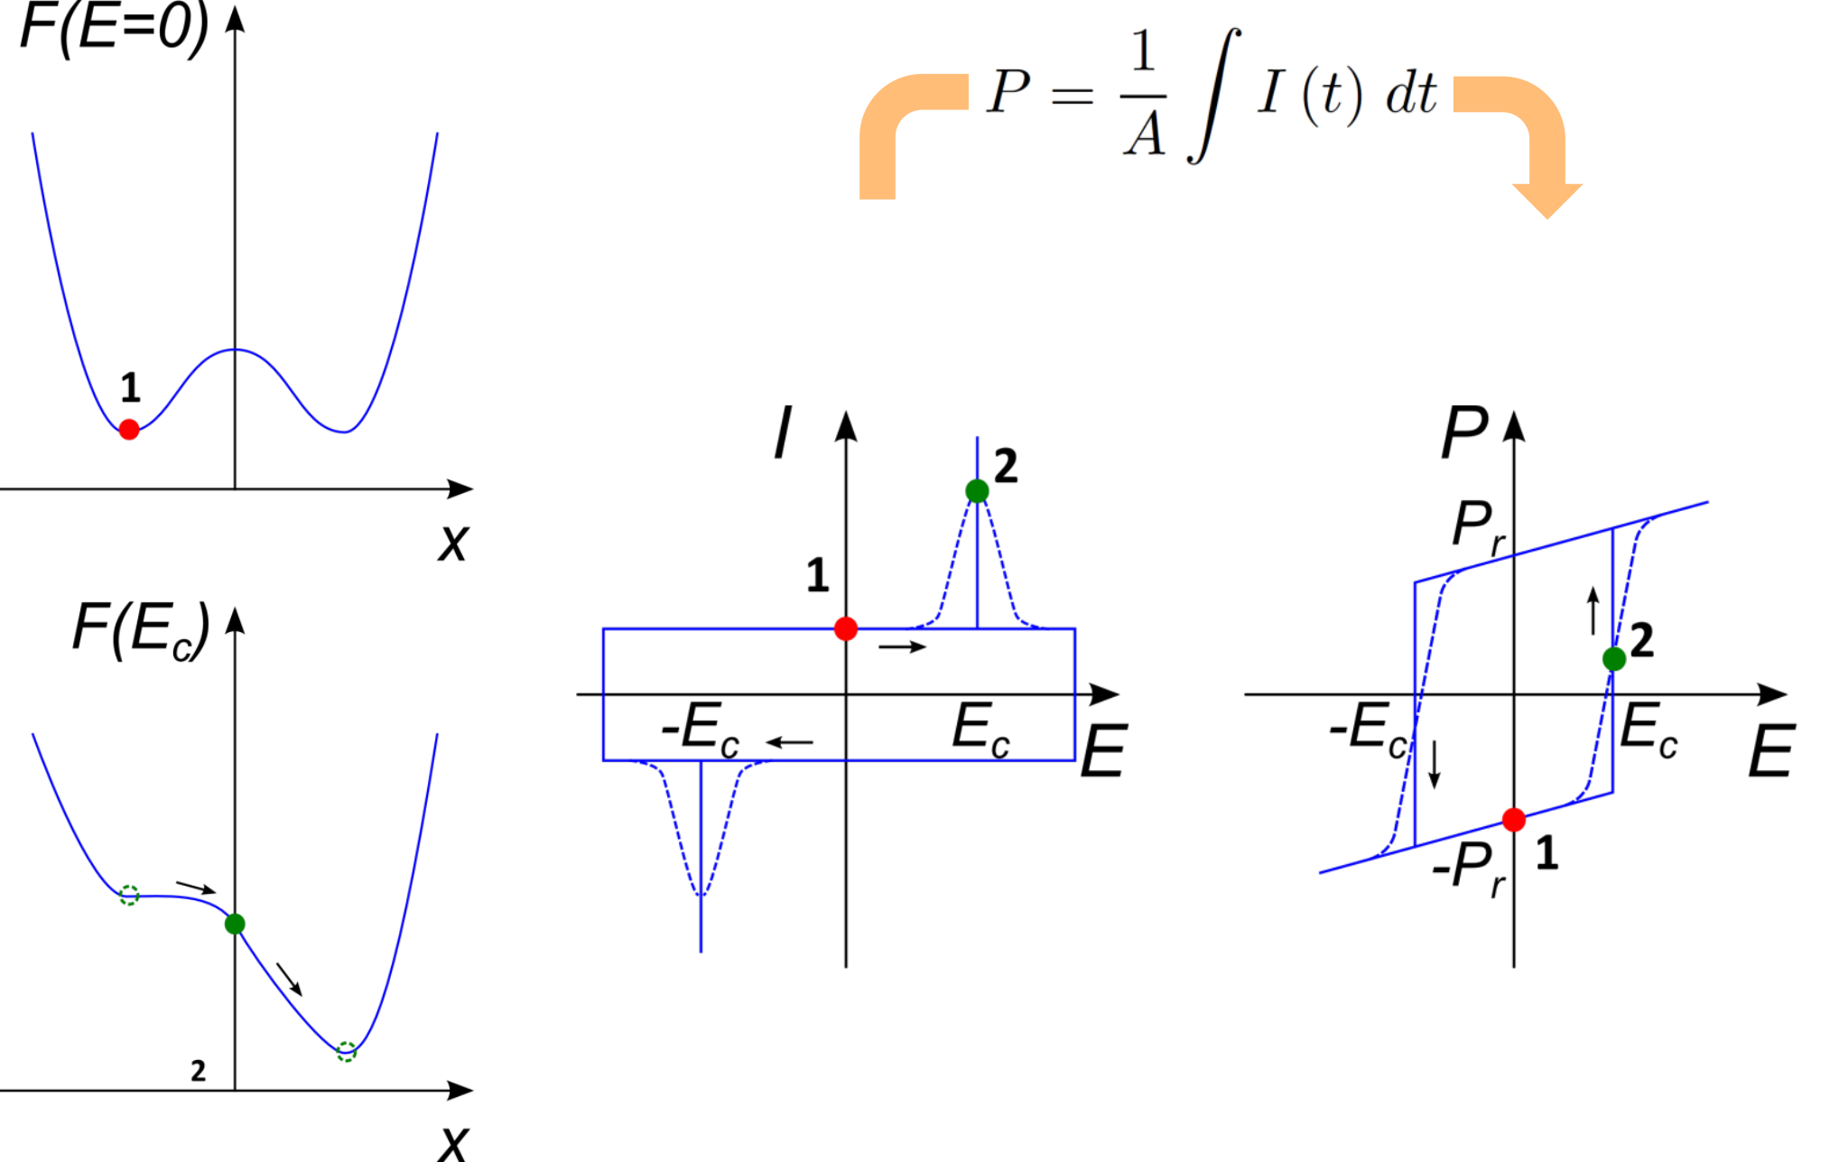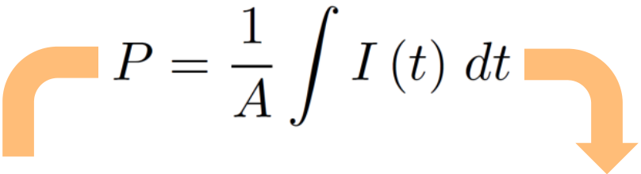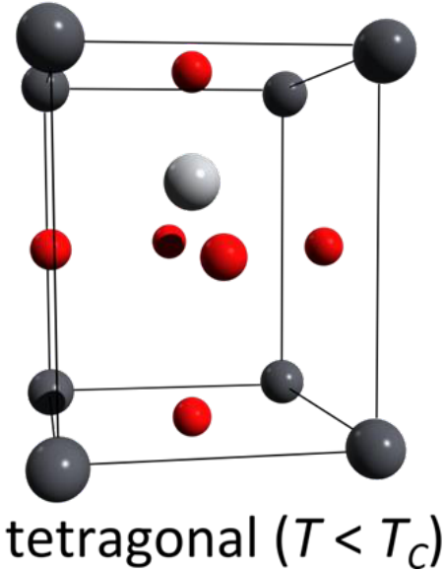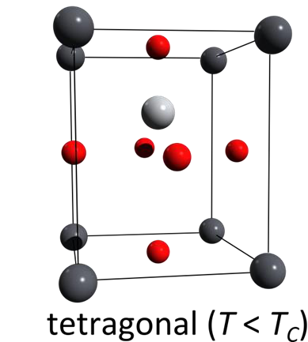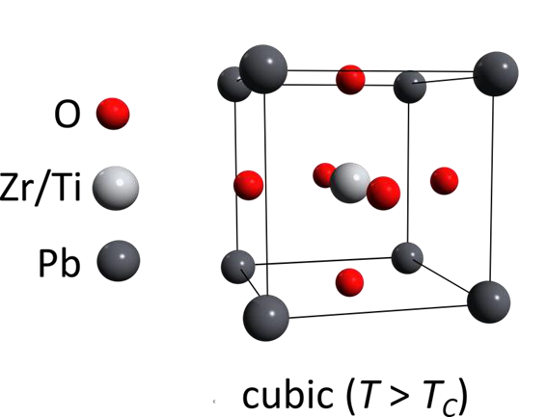

|  |  |  |
| --- | --- | --- |
| Ferroelectric crystal | Double well potential of ferroelectric material | Hysteresis |

■ Ferroelectrics have two stable polarization states that can be switched by applying an

electrical field

a t u d r e s d e n c o m p a n y

Types of Ferroelectric Memories 

|  |  |  |  |  |  |
| --- | --- | --- | --- | --- | --- |
| Capacitor based 1T/1C FeRAM cell | | Ferroelectric Tunnel junction (FTJ) | | Ferroelectric Field Effect Transistor (FeFET) | |
|  | |  | |  | |
| Capacitor based 2T/1C FeRAM gain cell | | | 3T universal ferroelectric memory cell | | |
|  | |  | | | |
| ■   | Three basic Memory cells: FeRAM, FeFET and FTJ  Charge on capacitor can also be amplified by a transistor leading to a 2T/1C FeRAM cell Using a FeFET instead on the capacitor a 3T cell that realizes all three variants can be obtained | | | | |
| a t u d r e s d e n | | | | | c o m p a n y |

Outline

|  |  |
| --- | --- |
| |  | | --- | | Introduction | |

|  |  |
| --- | --- |
| |  | | --- | | Ferroelectricity in Hafnium Oxide | |

Capacitor based Ferroelectric Random Access Memory

|  |  |
| --- | --- |
| |  | | --- | | Ferroelectric Tunnel Junction Memory | |

|  |
| --- |
| Other Applications  Ferroelectric Field Effect Transistor Memory |

|  |  |  |  |
| --- | --- | --- | --- |
| |  | | --- | | Negative Capacitance FET | | a t u d r e s d e n | c o m p a n y |

Ferroelectric Materials for Integration

|  |  |  |  |  |
| --- | --- | --- | --- | --- |
| ■  | Lead-Zirconium-Titanate PbZrxTi1-xO3 (PZT) | Strontium-Bismuth-Tantalate SrBi2Ta2O9 (SBT) | Orthorombic Hafnium Oxide X:HfO2 | |
| Parameters of ferroelectric materials    Hafnium Oxide is CMOS compatible  Hafnium Oxide has comparable remanent polarization and higher coercive field compared to perovskites | | | |
| a t u d r e s d e n | | | c o m p a n y |

Doped HfO2 vs. HfZrO2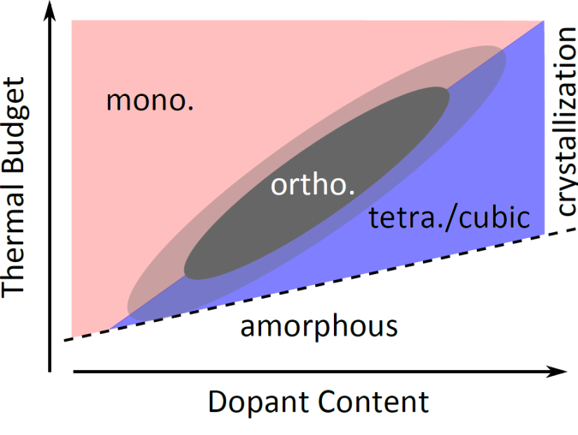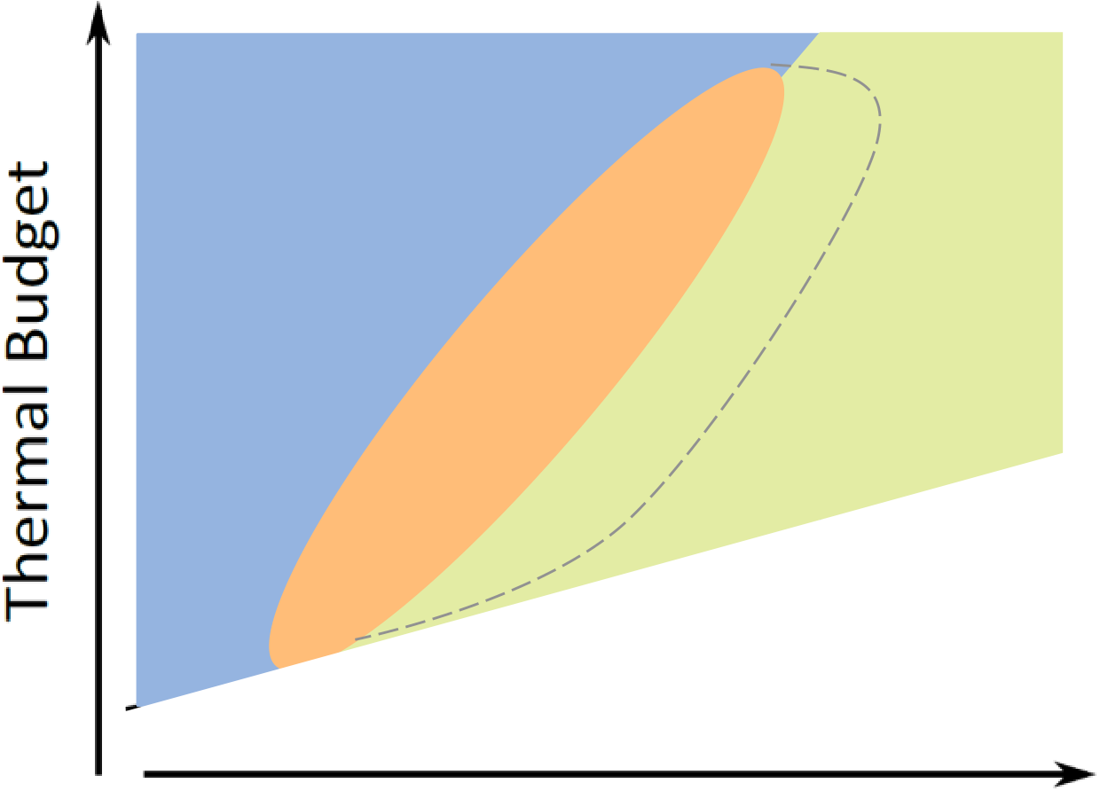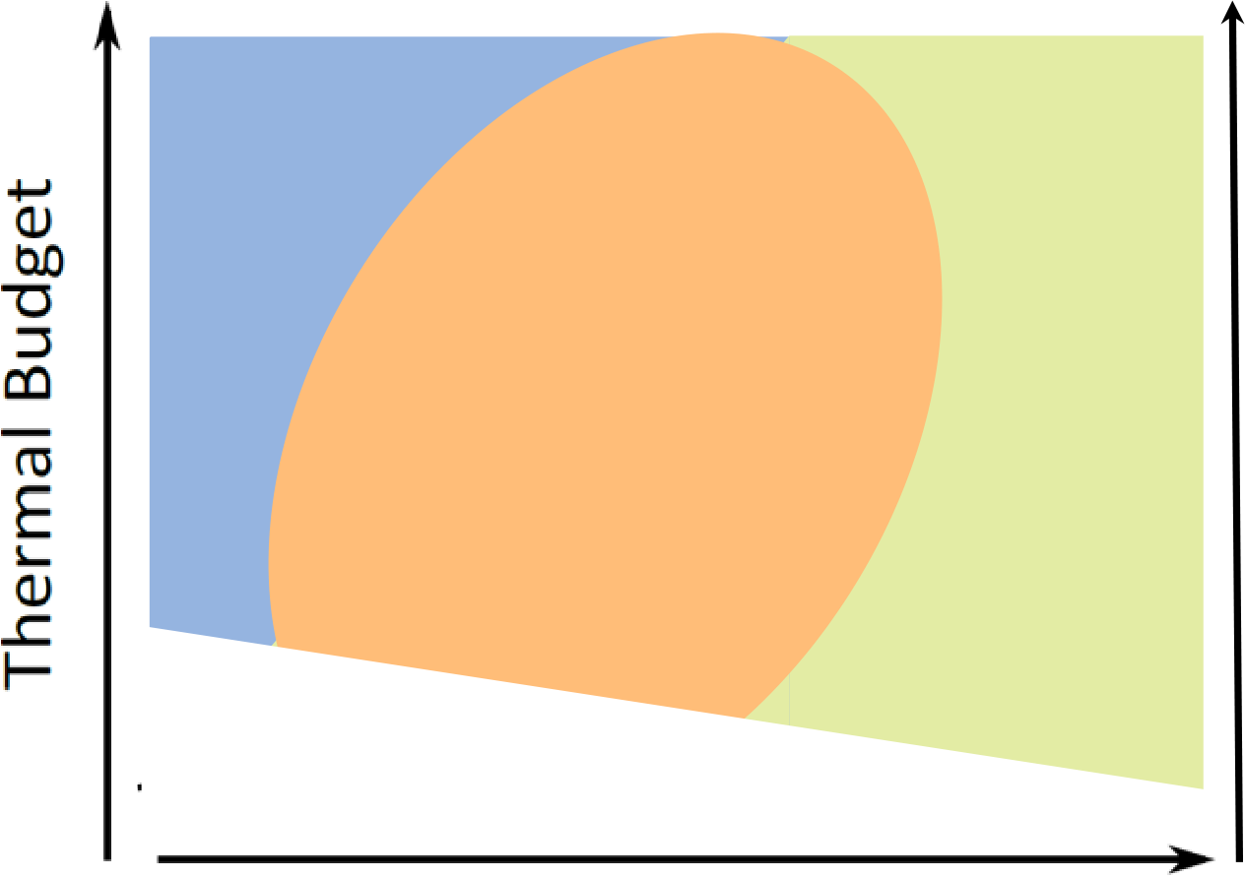

|  |  |  |  |  |
| --- | --- | --- | --- | --- |
| monoclinic | | cubic | monoclinic | tetragonal (AFE) |
| ortho- rhombic  (FE) | tetra (AFE) | orthorhombic  (FE) |
| amorphous | | amorphous |
| pure  HfO2 | | HfO2 | ZrO2 |

■ Doped HfO2: highest ferroelectric properties at ~ 2-3 mol% dopant concentration

■ HfZrO: broader dopant range; highest FE properties for Hf0.5Zr0.5O2

■ Under certain conditions also pure HfO2 can be made ferroelectric

|  |  |  |
| --- | --- | --- |
| |  | | --- | | Hofmann et al., JAP 2015 | | |
| a t u d r e s d e n a t u d r e s d e n | c o m p a n y c o m p a n y |

Comparison between HZO and PZT

|  |  |  |  |
| --- | --- | --- | --- |
| Comparison of Grain Size Distribution for Fe doped PZT and HZO | | Comparison of Parameters for HZO and Fe doped PZT | |
|  |  |  | |
| Field Cycling of HZO and Fe doped PZT | |
|  | |  | |
| ■ Degradation physics seems to be similar   PZT with Pt electrodes (non-optimized) were used to see the physical effects  Another proof for a real ferroelectric effect   Can we learn from the Optimization of PZT? F. Fengler et al., ESSDERC 2016 F. Fengler et al., Advanced Electronic Materials, 2017 | | | |
| a t u d r e s d e n | | | c o m p a n y |

Outline

|  |  |
| --- | --- |
| |  | | --- | | Introduction | |

|  |
| --- |
| Ferroelectricity in Hafnium Oxide |

|  |  |
| --- | --- |
| |  | | --- | | Capacitor based Ferroelectric Random Access Memory | |

|  |
| --- |
| Ferroelectric Tunnel Junction Memory |

|  |
| --- |
| Other Applications  Ferroelectric Field Effect Transistor Memory |

|  |  |  |  |
| --- | --- | --- | --- |
| |  | | --- | | Negative Capacitance FET | | a t u d r e s d e n | c o m p a n y |

Capacitor based Ferroelectric Random Access Memory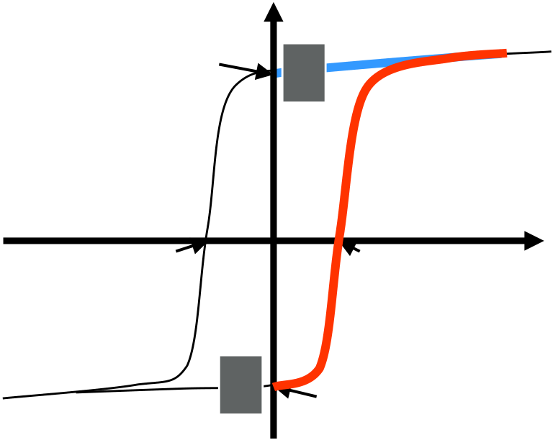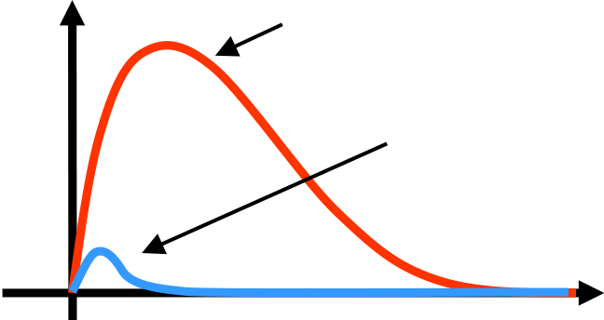

Read operation for a ferroelectric capacitor

|  |  |  |  |
| --- | --- | --- | --- |
| Writing „1“ Writing „0“    Polarization P Reading | | Current | Reading „1“ |
| (switching) |
| P+ | **0** | Reading „0“ |

(non-switching)

|  |  |  |  |  |
| --- | --- | --- | --- | --- |
| UC- | **1** | UC+ | Voltage U | Time t |
| P- |

■ During read operation capacitor is polarized in one direction   
■ The transient current charges the bit line capacitor differently depending on the stored polarization state  
■ Therefore read operation is destructive (same as for DRAM), and must be completed by writing the initial data back

|  |  |  |
| --- | --- | --- |
| |  | | --- | | T. Mikolajick, Encyclopedia of Materials Science, Elsevier 2002  T. Mikolajick, Reference Module in Materials Science and Materials Engineering, Elsevier 2016 | |  |
| a t u d r e s d e n | c o m p a n y |

Capacitor based Ferroelectric Random Access Memory

|  |  |
| --- | --- |
| Read operation in an FeRAM cell | Charge required for reading |

|  |  |  |
| --- | --- | --- |
|  | |  |
| |  | | --- | | M. Pešić et al., NVMTS 2017 | | |  | | --- | | K. Maruyama et al., Fujitsu Sci. Techn. J., 2005 | | |

■ The read operation starts by precharging the bit line to 0V (unlike DRAM)   
■ Then a voltage pulse is applied to the plate line   
■ Since for higher integration densities the cell size and hence capacitor area are scaled down, higher charge per area and thus higher remanent polarization are required to ensure stable read operation.

|  |  |
| --- | --- |
| a t u d r e s d e n | c o m p a n y |

Capacitor based Ferroelectric Random Access Memory Scaling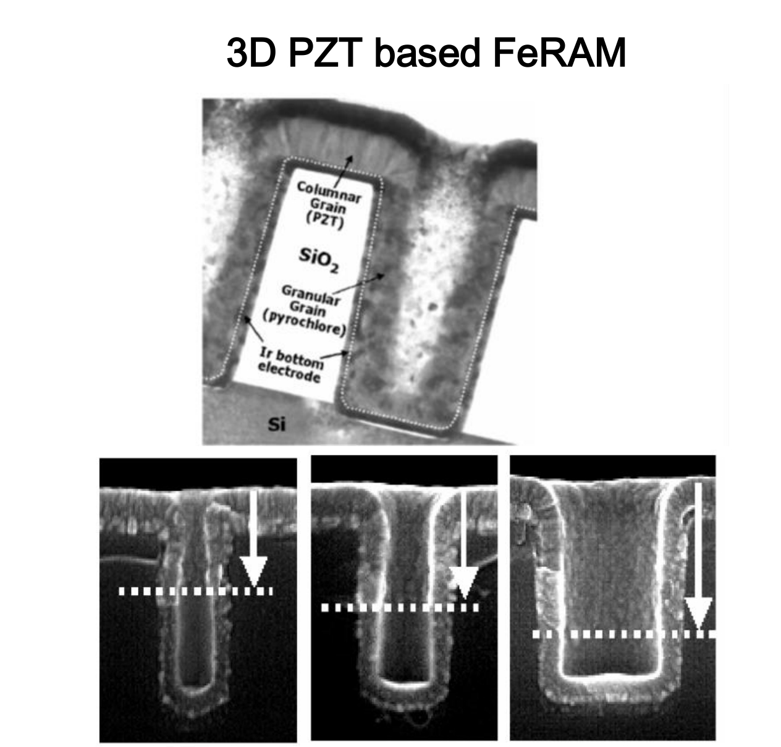

|  |  |
| --- | --- |
| Scaling of DRAM and FeRAM | 3D PZT based FeRAM |

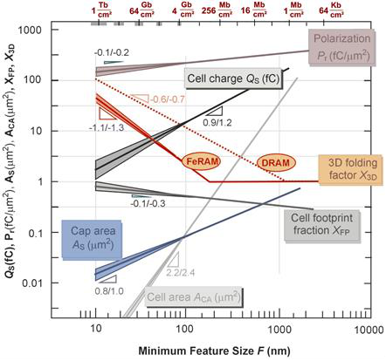

|  |  |  |  |
| --- | --- | --- | --- |
| |  | | --- | | R. Waser, in: Materials for Information Technology, Springer 2005 | | |  | | --- | | J.-M. Koo et al., IEDM, 2005 | |

■ For scaling below 100nm feature sizes 3D capacitors (like in DRAM) are required No solution exists to deposit the complex perovskites and electrode materials

|  |  |
| --- | --- |
| a t u d r e s d e n | c o m p a n y |

Capacitor based Ferroelectric Random Access Memory 3D capacitors using Al:HfO2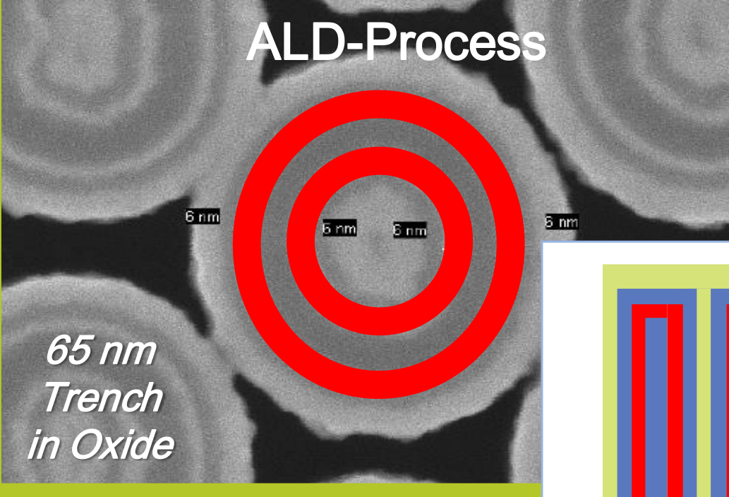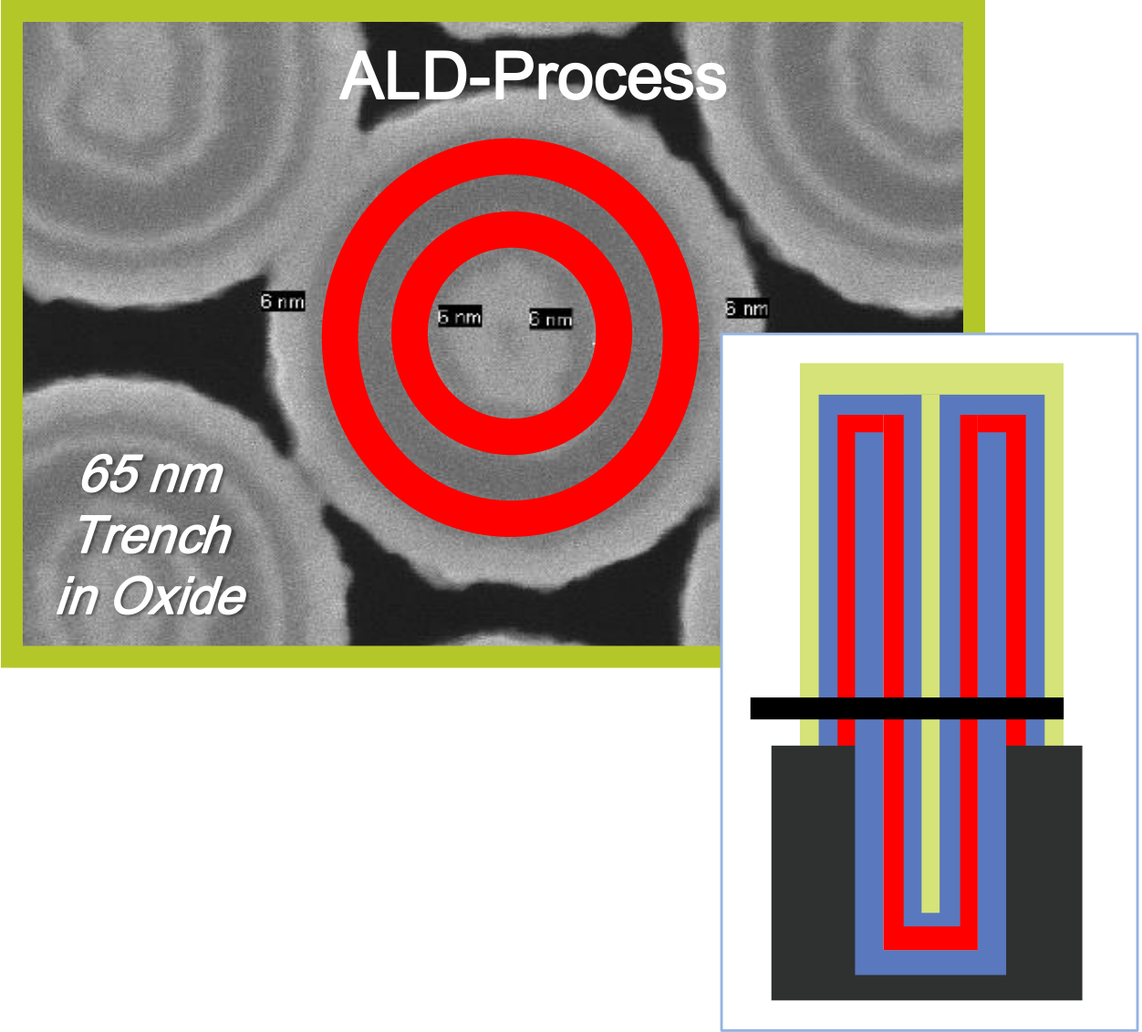

|  |  |
| --- | --- |
| Step coverage of ALD HfO2  ALD-Process  65 nm  Trench  in Oxide | Polarization per footprint of 2D and 3D structure |
|  | |

|  |  |
| --- | --- |
| |  | | --- | | J. Müller et al., IEDM 2013 | |

|  |  |
| --- | --- |
| |  | | --- | | P. Polakowski, IMW 2014 | |

■ Improved 3D scaling potential similar to DRAM for HfO2 based FRAM FE effects are almost fully explored even in 3D structures

|  |  |
| --- | --- |
| a t u d r e s d e n | c o m p a n y |

Capacitor based Ferroelectric Random Access Memory 3D capacitors using ferroelectric HfO2

Comparison between stacked DRAM and stacked FeRAM at same groundrule

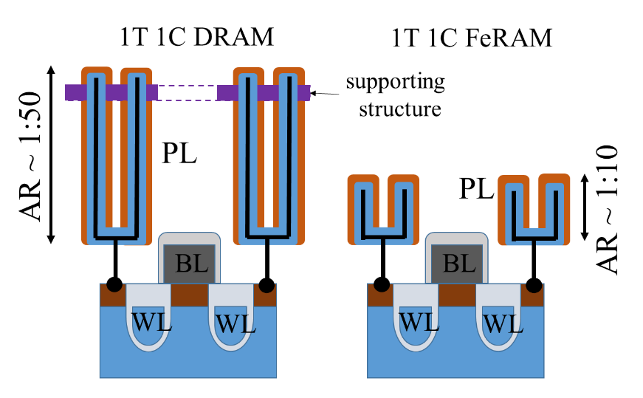

|  |
| --- |
| S. Slesazeck et al. IWCM2 2018 |

■ Less area required due to much higher polarization charge compared to capacitor charge  
■ In a 3D structure this results in a significantly reduced aspect ratio   
 → simpler to master technology

|  |  |
| --- | --- |
| a t u d r e s d e n | c o m p a n y |

Capacitor based 3T cell

Operation of 3T cell in FeRAM mode

|  |  |
| --- | --- |
| 3T universal ferroelectric memory cell |  |

■ Charging of an internal node requires much lower switched charge Need additional transistors to control and amplify the charge Gate capacitor of a FeFET can be used as the storage capacitor

|  |  |  |
| --- | --- | --- |
| |  | | --- | | S. Slesazeck et al. IMW 2019 | | |
| a t u d r e s d e n | c o m p a n y |

Field cycling of ferroelectric HfO2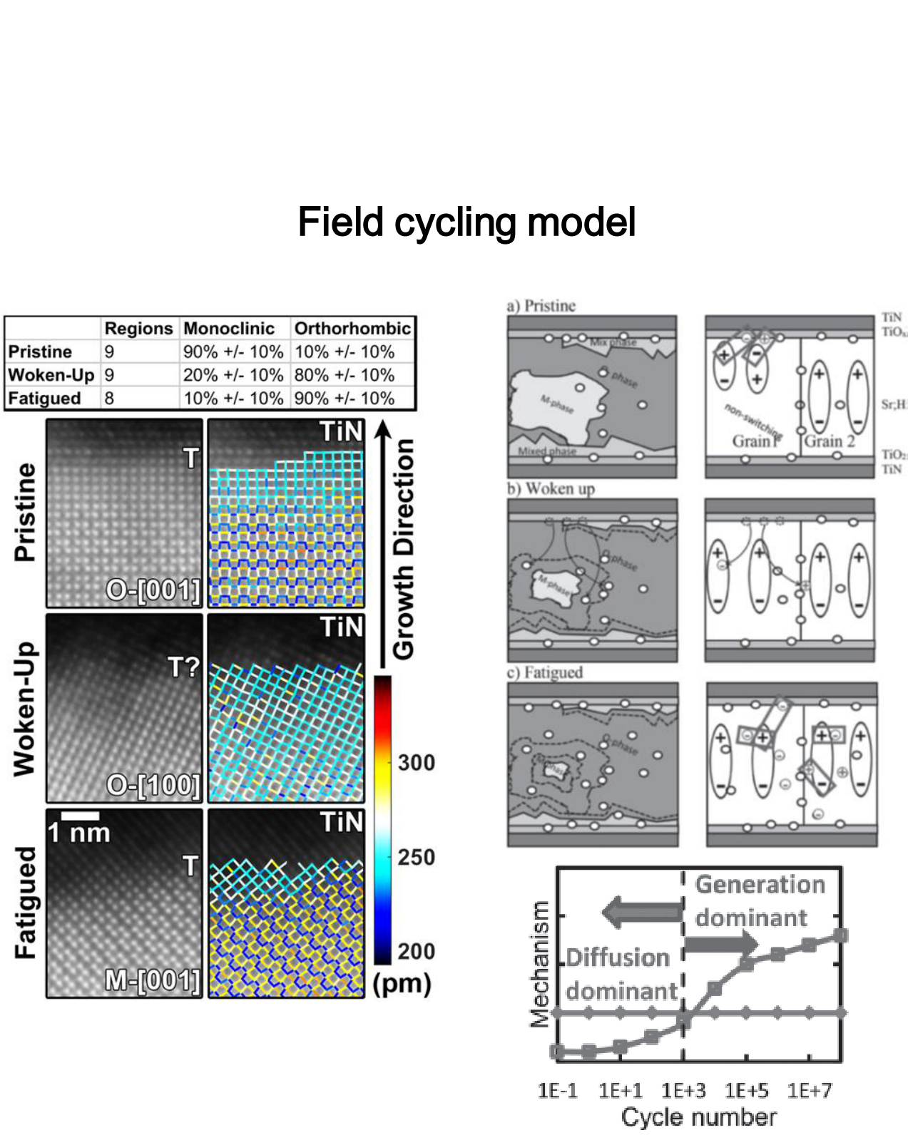

|  |  |
| --- | --- |
| Polarization and leakage during field cycling | Field cycling model |

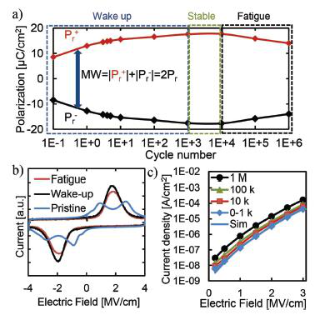

|  |  |  |  |
| --- | --- | --- | --- |
| |  | | --- | | M. Pesic et al., Advanced Functional Materials 2016 | | |  | | --- | | E. Grimley et al., Advanced Electronic Materials, 2016 | |

■ Wake-up and fatigue is typical in electrical field cycling  
■ Wake-up dominated by trapped charge redistribution and phase transformation Fatigue dominated by trap generation and subsequent trapping and domain pinning

a t u d r e s d e n c o m p a n y



|  |  |  |  |
| --- | --- | --- | --- |
| **Polarization-Voltage curves in** | **Endurance and remanent polarization of** | | |
| **doped HfO2**  **HfO2 doped with different amount of Silicon**   DRAM has infinite endurance     DRAM capacitor uses ZrO2 dielectric  ZrO2 is tetragonal (high-k)  The tetragonal phase is responsible for anti-ferroelectric behavior Antiferroelectrics have higher endurance than FEs  But…Antiferroelectrics have no remanent polarization! | | | |
| |  | | --- | | M.Pešić et al. IEDM 2016 | | | |  | | --- | | M.Pešić et al. ESSDRC 2017 | | |
| a t u d r e s d e n | | | c o m p a n y |

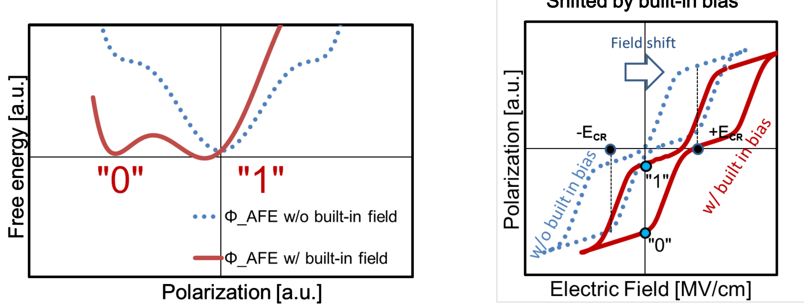

|  |  |
| --- | --- |
| Energy landscape of an antiferroelectric | P-E curve of antiferroelectric Shifted by built-in bias |

■ Basic antiferroelectric configuration  
■ Different WF electrodes → introduction of internal bias Centering of one of the antiferroelectric branches Switching between polarized and non-polarized state

|  |  |  |
| --- | --- | --- |
| |  | | --- | | M. Pešić et al. IEDM 2016, Adv. Funct. Mat. 2016, ESSDERC 2017 | | |
| a t u d r e s d e n | c o m p a n y |



|  |  |
| --- | --- |
| I-V and P-V curve of antiferroelectric using TiN bottom and TIN top electrode | I-V and P-V curve of antiferroelectric  using TiN bottom and RuOx top electrode |

■ Antiferroelectric behavior is observed for symmetric stack using a TiN top electrode Using a RuOx top electrode a shift of the hysteresis by ~ 0.8 V is observed  
■ In principle also fixed charges or fixed dipoles can create the required bias field but the resulting depolarization field makes it more complictaed

|  |  |  |
| --- | --- | --- |
| |  | | --- | | M.Pešić et al. Journal of the EDS 2018 | | |
| a t u d r e s d e n | c o m p a n y |

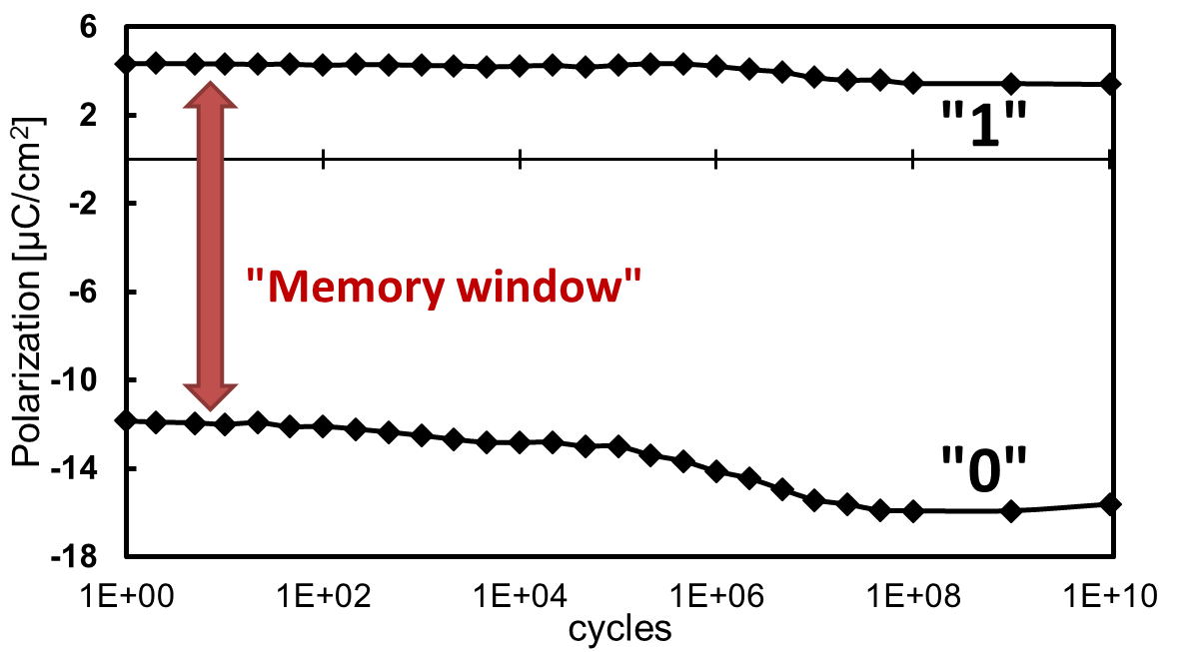

|  |  |
| --- | --- |
| Cycling of antiferroelectric with asymmetric electrodes  Non-polarized  Polarized state  ±3V @100kHz | Retention of antiferroelectric with asymmetric electrodes |

Typical FE retention sequences

|  |  |  |
| --- | --- | --- |
| ■ No breakdown or fatigue after 1010cycles Imprint occurs after cycling   The imprint stabilizes the polarized state Retention @ 100 °C → Nonvolatile |  | |
| |  | | --- | | M. Pešić et al., ESSDERC 2017 | | |  | | --- | | M.Pešić et al. Journal of the EDS 2018 | | |
|  | a t u d r e s d e n | c o m p a n y |

Outline

|  |  |
| --- | --- |
| |  | | --- | | Introduction | |

|  |
| --- |
| Ferroelectricity in Hafnium Oxide |

|  |  |
| --- | --- |
| |  | | --- | | Capacitor based Ferroelectric Random Access Memory | |

|  |  |
| --- | --- |
| |  | | --- | | Ferroelectric Tunnel Junction Memory | |

|  |  |
| --- | --- |
| |  | | --- | | Ferroelectric Field Effect Transistor Memory | |

|  |  |  |  |
| --- | --- | --- | --- |
| |  | | --- | | Negative Capacitance FET | | a t u d r e s d e n | c o m p a n y |



|  |  |  |
| --- | --- | --- |
| metal/ferroelectric/metal (MFM) | Remanent Polarization as a function of film thickness for Si:HfO2 | metal/ferroelectric/  insulator/metal (MFIM) |
|  |  |
|  |
|  |
|  |

|  |  |
| --- | --- |
| |  | | --- | | C. Richter et al., Advanced Electronic Materials, 2017 | |

■ Stable ferroelectric properties in hafnia-based compounds only for thickness > 6-8 nm Solution: additional dielectric layer  
■ Change of potential landscape → different tunneling coefficients

|  |  |
| --- | --- |
| a t u d r e s d e n | c o m p a n y |



|  |  |
| --- | --- |
| Test structure schematic and TEM image       Hf0.5Zr0.5O2 as switching layer  Al2O3 as dielectric tunneling layer Symmetric metal TiN electrodes | Band Diagram and I-V curve for both polarization directions |

|  |  |  |
| --- | --- | --- |
| |  | | --- | | B. Max et al., ESSDERC 2018, JEDS 2019 in review | | |
| a t u d r e s d e n | c o m p a n y |

Tunneling layer thickness variation

|  |  |  |
| --- | --- | --- |
| Schematic | I-V curves showing ferroelectric switching | Triangular voltage pulses |

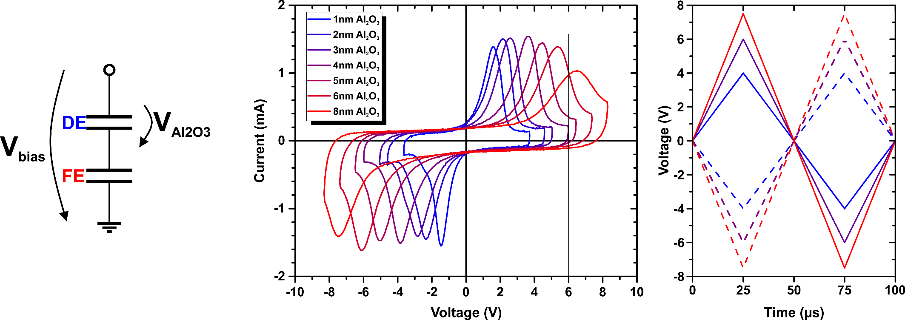

■ Additional Al2O3 layer requires higher switching voltages  
■ Pup an Pdown can be set by triangular voltage pulses while simultaneously

|  |  |  |  |
| --- | --- | --- | --- |
| measuring the I-V hysteresis | |  | | --- | | B. Max et al., ESSDERC 2018 | | |
|  | a t u d r e s d e n | c o m p a n y |

Tunneling layer thickness variation

|  |  |
| --- | --- |
| Switching and reading behavior of two layer FTJ using 1nm, 3nm and 6nm tunneling layer | On/Off ration as a function of tunneling barrier thickness |
|  | |  | | --- | | B. Max et al., ESSDERC 2018 | |

■ With very thin Al2O3 the switching current is higher than the reading current With very thick Al2O3 the tunneling current is very low  
■ Stable device operation is possible only in a certain thickness window

a t u d r e s d e n c o m p a n y

Two Layer Ferroelectric Tunnel Junction Programming behavior

|  |  |  |
| --- | --- | --- |
| Switching for different maximum voltages | Cycling with different maximum voltages | Current after switching with different voltages and different duration |

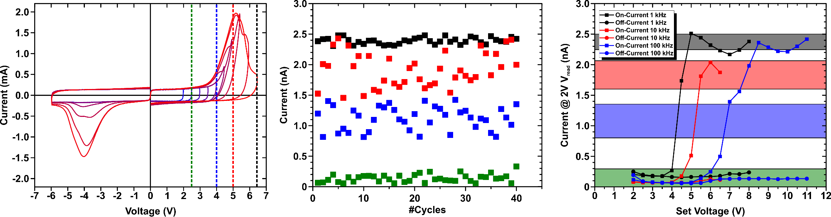

|  |  |  |  |
| --- | --- | --- | --- |
| ■ Intermediate states can be set by varying set pulse amplitude  High cycle-to-cycle stability for setting   different states  Multi-level operation possible   |  | | --- | | B. Max et al., JEDS 2019 in review | | Cumulative distributions for four different set resistance states | |
| a t u d r e s d e n | c o m p a n y |

Two Layer Ferroelectric Tunnel Junction   
Endurance   
 Remanent polarization of ferroelectric layer used in two layer FTJ as a function of field cycling

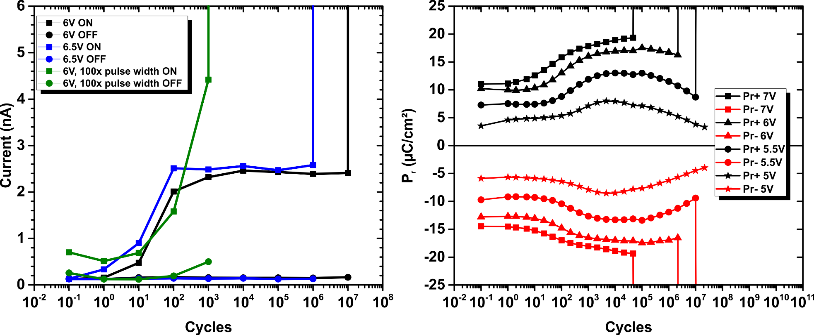

■ More pronounced wake-up by introduction of additional dielectric layer Correlation between on-state increase and wake-up behavior of the ferroelectric layer

|  |  |  |
| --- | --- | --- |
| |  | | --- | | B. Max et al., JEDS 2019 in review | | |
| a t u d r e s d e n | c o m p a n y |



|  |  |
| --- | --- |
| Two Layer Ferroelectric Tunnel Junction | |
| Retention   Retention of two layer FTJ measured at  different temperatures | Retention of two layer FTJ measured with different external bias |
|  |  |

■ Extrapolated retention is almost 10 years at room temperature  
■ Probable root cause: depolarization field by double capacitor structure External bias can suppress or enhance the depolarization field

|  |  |  |
| --- | --- | --- |
| |  | | --- | | B. Max et al., IMW 2019 | | |
| a t u d r e s d e n | c o m p a n y |

3T ferroelectric cell in Ferroelectric Tunnel Junction mode

Operation of 3T cell in FTJ mode

|  |  |
| --- | --- |
| 3T universal ferroelectric memory cell |  |

■ Tunneling current is used to charge internal node  
■ Need additional transistors to control and amplify the charge Gate stack of FeFET is used as multi-layer FTJ

|  |  |  |
| --- | --- | --- |
| |  | | --- | | S. Slesazeck et al. IMW 2019 | | |
| a t u d r e s d e n | c o m p a n y |

Antiferroelectric two layer tunnel junction

|  |  |  |
| --- | --- | --- |
| **Built-in field by dipoles or** | **Band diagram of 2 layer FTJ** | **Simulated I-V curve of two** |
| **fixed charges** | **with FE and AFE switching layer** | **layer FTJ with FE and AFE** |
|  | **switching layer** |
|  |
|  |

■ Tunnel junction can use antiferroelectric layer as well  
■ Shift if the curve by interface engineering gives a natural fit to the two layer structure

|  |  |  |
| --- | --- | --- |
| |  | | --- | | M.Pešić et al., Journal of the EDS 2018 | | |
| a t u d r e s d e n | c o m p a n y |

Outline

|  |  |
| --- | --- |
| |  | | --- | | Introduction | |

|  |
| --- |
| Ferroelectricity in Hafnium Oxide |

|  |  |
| --- | --- |
| |  | | --- | | Capacitor based Ferroelectric Random Access Memory | |

|  |  |
| --- | --- |
| |  | | --- | | Ferroelectric Tunnel Junction Memory | |

|  |  |
| --- | --- |
| |  | | --- | | Ferroelectric Field Effect Transistor Memory | |

|  |  |  |  |
| --- | --- | --- | --- |
| |  | | --- | | Negative Capacitance FET | | a t u d r e s d e n | c o m p a n y |

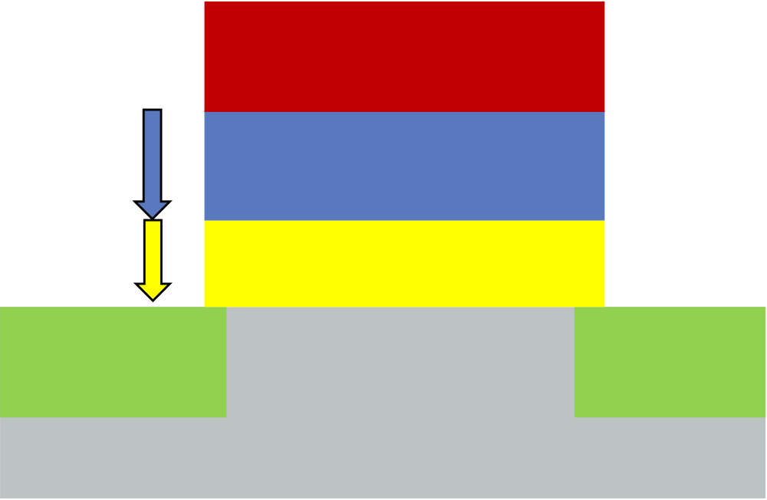

|  |  |  |  |  |
| --- | --- | --- | --- | --- |
| EFe | Generic ferroelectric FET | | Gate voltage | |
| Gate | | 𝑉𝐺 = 𝜑𝑆 + 𝑄𝑠𝑐 𝜑𝑆 𝐶𝑆𝑡𝑎𝑐𝑘 | + 𝐸𝐹𝑒 ∙ 𝑑𝐹𝑒 |
| Ferroelectric | dFe |
| At flatband | |
| Dielectric | dI |
| EI |

𝑉𝐹𝐵 = 𝐸𝐹𝑒(𝑃 = 0) ∙ 𝑑𝐹𝑒

Memory window

𝑀𝑊 = 𝑉𝐹𝐵+ − 𝑉𝐹𝐵− ≈ 2 ∙ 𝐸𝐶 ∙ 𝑑𝐹𝑒

■ Qsc is the space charge in the silicon and Cstack is the capacitance of the series connection of ferroelectric and dielectric capacitor (assumption: No trapped or fixed charge)  
■ The nonlinear and switching behavior of the ferroelectric as a function of the electrical field modifies the I-V characteristics of a FeFET compared to a normal MOSFET  
■ The ferroelectric switching leads to hysteresis  
■ The memory window depends on the coercive field and the thickness of the material

|  |  |
| --- | --- |
| a t u d r e s d e n | c o m p a n y |

Ferroelectric Field Effect Transistor Array integration in 28nm and 22nm technology

|  |  |  |  |  |  |  |
| --- | --- | --- | --- | --- | --- | --- |
| Layout of 64kArray | Cross sections of 28nm logic FETs and FeFET | | | | 22nm FDSOI FeFET device | |
|  |  | | | | |  |
| I-V curves for low and high VT states of 22nm FDSOI FeFET device | | | Checkerboard and complex pattern stored in 64k Array | Cycling endurance behavior | | |
|  | |  | |  | | |
| ■ Cell transistor only differs in HfO2 layer details Periphery devices are not affected | | | | | |  | | --- | | M. Trentzsch et al., IEDM 2016 | | |

|  |  |  |
| --- | --- | --- |
| |  | | --- | | S. Dünkel et al., IEDM 2017 | | |
| a t u d r e s d e n | c o m p a n y |

3T cell in Ferroelectric Field Effect Transistor mode Operation of 3T cell in FeFET mode

|  |
| --- |
| 3T universal ferroelectric memory cell   Typical 1T FeFET characteristics achieved |

|  |  |  |
| --- | --- | --- |
| |  | | --- | | S. Slesazeck et al. IMW 2019 | | |
| a t u d r e s d e n | c o m p a n y |

FeFET endurance improvement by self heating

|  |  |  |  |  |  |  |  |  |  |  |  |  |  |  |  |  |  |  |  |
| --- | --- | --- | --- | --- | --- | --- | --- | --- | --- | --- | --- | --- | --- | --- | --- | --- | --- | --- | --- |
| Typical cycling characteristics of 28nm FeFET cell | | | | | | | | 1 | recovery by self heating | | | | | | | | | | Improved endurance by self heating |
| 300 | | | | | | | | 1 | V 104cyc. heat 104cyc. heat  10  -5 self-heat.  300°C/2h (c) 1  10 -6 (a) VP t 0.5  ID [A] VG  VT [V]  -7 0  VG  10 1  (c)  -1 -0.5-0.5  -1  0   |  |  |  |  |  |  | | --- | --- | --- | --- | --- | --- | |  |  |  |  |  |  | | |
|  |  |  |  |  |  |  |  |
|  |  |  |  |  |  |  |  |
|  |  |  |  |  |  |  |  |  |  |  |  |  |  |  |  |  |
|  |  |  |  |  |  |  |  |  |  |  |  |  |  |  |  |  |
|  |  |  |  |  |  |  |  |  |  |  |  |  |  |  |  |  |
|  |  |  |  |  |  |  |  |  |  |  |  |  |  |  |  |  |
|  |  |  |  |  |  |  |  |  |  |  |  |  |  |  |  |  |
|  |  |  |  |  |  |  |  |  |  |  |  |  |  |  |  |  |

FeFET improvement by thicker ferroelectric

|  |  |  |  |  |  |  |  |  |  |  |  |  |  |  |
| --- | --- | --- | --- | --- | --- | --- | --- | --- | --- | --- | --- | --- | --- | --- |
| Schematic, TEM cross section and I-V curve of FeFET having 20nm Fe-HfO2 | Development of memory window in Cycling of FeFET having  FeFETs having 10nm and 20nm 20nm Fe-HfO2  Fe-HfO2  (a) VG VP  ... t   10  10  -5  -6   PRG  ERS  ID [A]  VN R R R R 10-7  10-8 (a)  (b) 3 0 1 2 3  0  3  2  0  1   |  |  |  |  |  |  | | --- | --- | --- | --- | --- | --- | |  |  |  |  |  |  | |  |  |  |  |  |  | |  |
|  |



|  |  |  |  |
| --- | --- | --- | --- |
| Reconfigurable NAND/NOR gate | Principle of reconfigurable NAND/NOR gate | Truth tables for NAND and NOR gate | |
| ■ One input is stored in form of the ferroelectric polarization | |
| ■ The second input is applied to the gate  Reconfiguration can be done by the source voltage or by the back gate voltage in the case of FDSOI | | |  | | --- | | E. Breyer et al., IEDM 2017 | | |
| |  | | --- | | E. Breyer et al., ISCAS 2018 | | |
| a t u d r e s d e n | c o m p a n y |



|  |  |  |  |  |
| --- | --- | --- | --- | --- |
| 2T NOR cell, array and measurement results | 4-to-1 MUX realizing LUT for a 2 input logic gate | | Experimental Verification of AND, NOR and XOR function     |  | | --- | | S. Beyer, NVMTS 2018 | |
|  | |  |
| ■ FeFET can be integrated next to standard FET Look-up table can be stored in FeFET  Different logic functions can be realized | | |

|  |  |  |
| --- | --- | --- |
| |  | | --- | | E. Breyer et al., ESSDERC 2019 | | |
| a t u d r e s d e n | c o m p a n y |

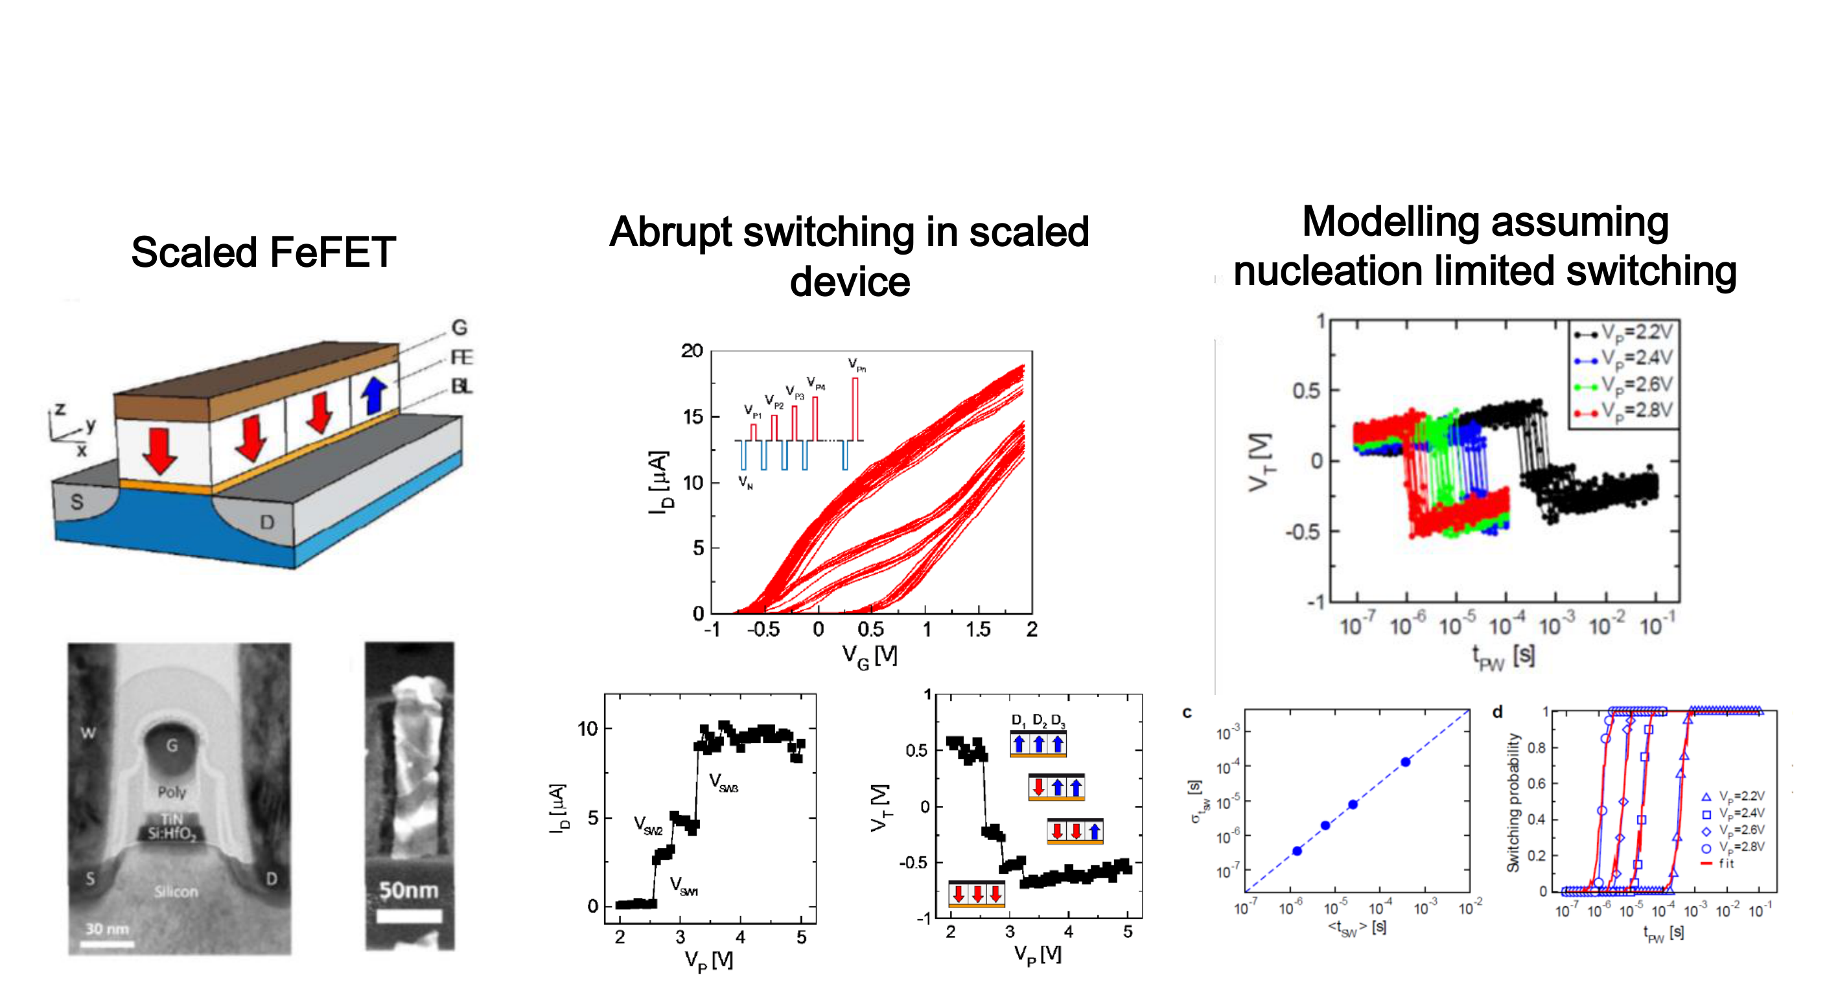

|  |  |  |
| --- | --- | --- |
| Scaled FeFET | Abrupt switching in scaled device | Modelling assuming  nucleation limited switching |

■ Clear indication of single domain switching in small scaled HfO2-based FeFET

devices

■ Can be used to deeply analyze switching of single domains

|  |  |  |
| --- | --- | --- |
| |  | | --- | | H. Mulaosmanovic et al., IEDM 2015 and ACS Materials and Interfaces 2017 | | |
| a t u d r e s d e n | c o m p a n y |



|  |  |
| --- | --- |
| FeFET operated as synapse | Pulse trains and results for STDP like behavior |

■ In a multi domain device the channel current can be controlled either by the voltage or the time of the programming pulses  
■ Using an additional resistor a synapse can be mimicked  
■ STDP –like behavior is obtained

|  |  |  |
| --- | --- | --- |
| |  | | --- | | H. Mulaosmanovic et al., VLSI 2017 | | |
| a t u d r e s d e n | c o m p a n y |

Ferroelectric 3D Test   
 structure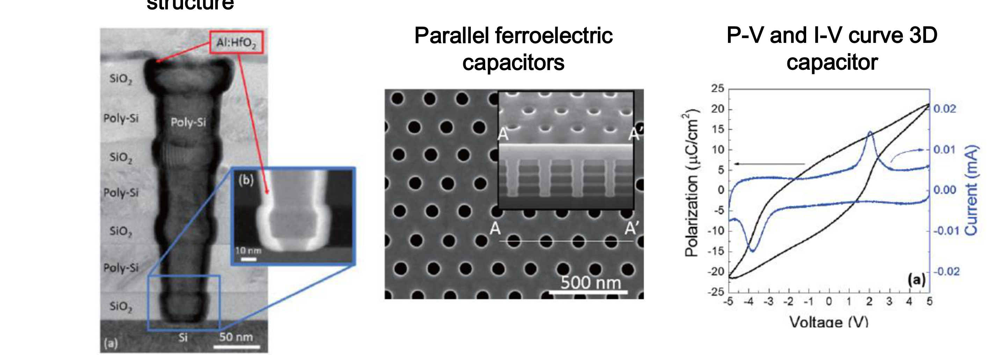

|  |  |  |
| --- | --- | --- |
| ■ | Parallel ferroelectric   capacitors | P-V and I-V curve 3D |
| capacitor |
| First demonstration of 3D capacitors using Al-doped HfO2 Promising hysteresis shown |
| ■ |

|  |  |  |
| --- | --- | --- |
| |  | | --- | | K. Florent. et al., VLSI Technology, 2017 | | |
| a t u d r e s d e n | c o m p a n y |

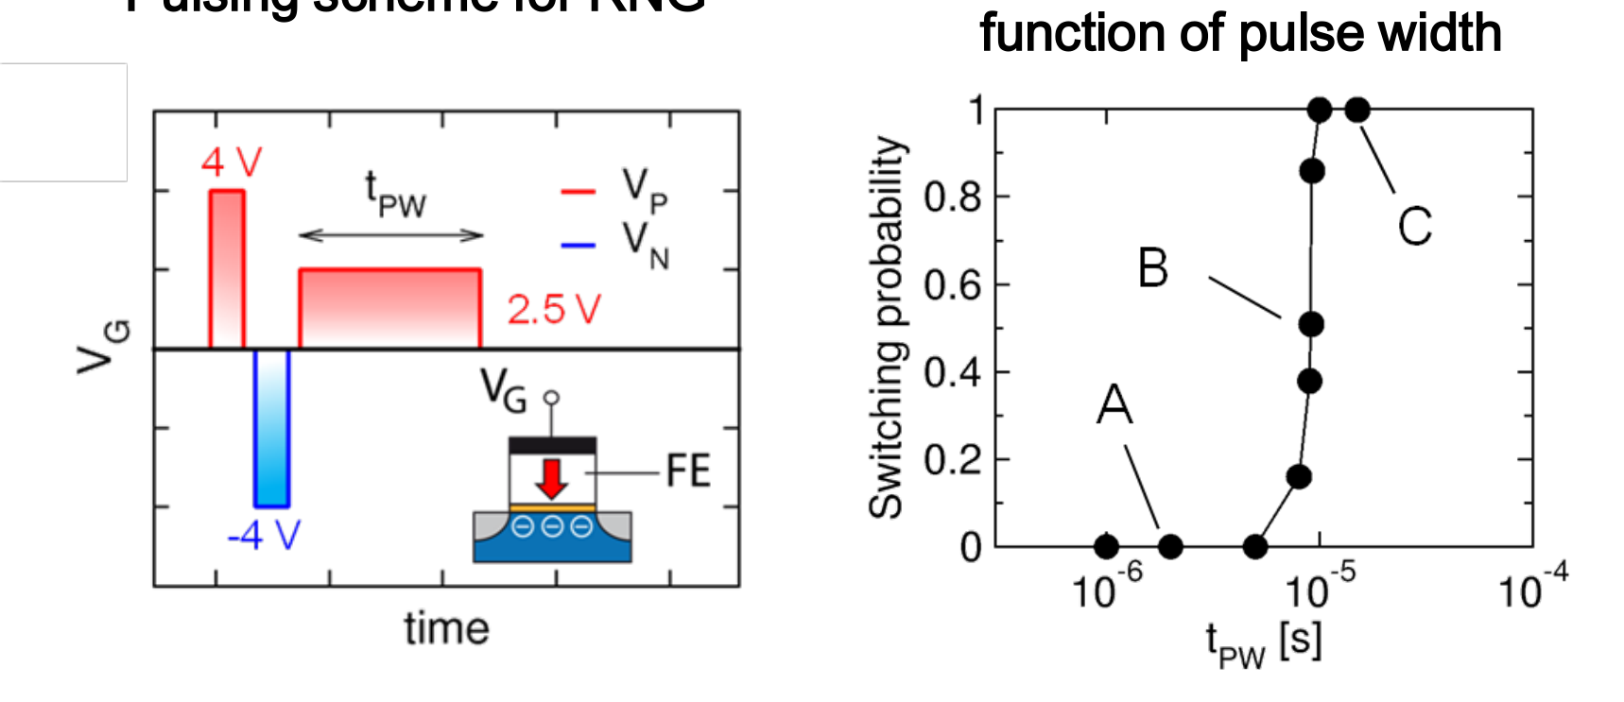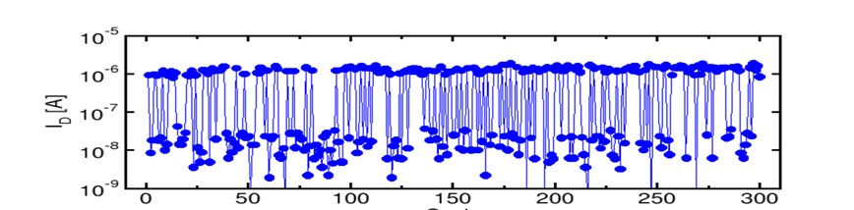

|  |  |  |
| --- | --- | --- |
| Pulsing scheme for RNG | Switching probability as a function of pulse width | Cumulative distribution of current after switching with fixed conditions |

Drain current at VG=0V for 300 switching cycles in the stochastic region

■ In scaled device there is a stochastic switching region for certain pulse width that can be exploited for random number generation (RNG)  
■ With proper selection of the pulsing conditions equal probability for high and low current after switching can be obtained

|  |  |  |
| --- | --- | --- |
| |  | | --- | | H. Mulaosmanovic et al., IEEE EDL 2017 | | |
| a t u d r e s d e n | c o m p a n y |

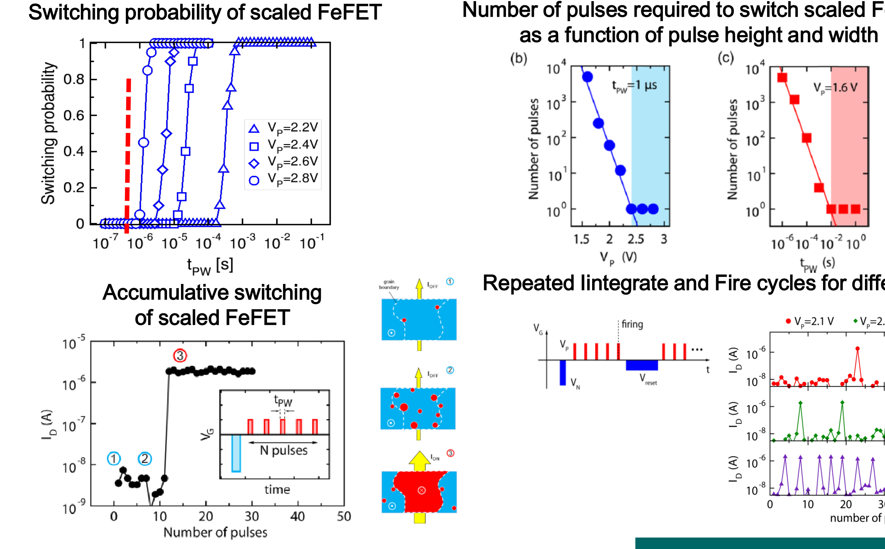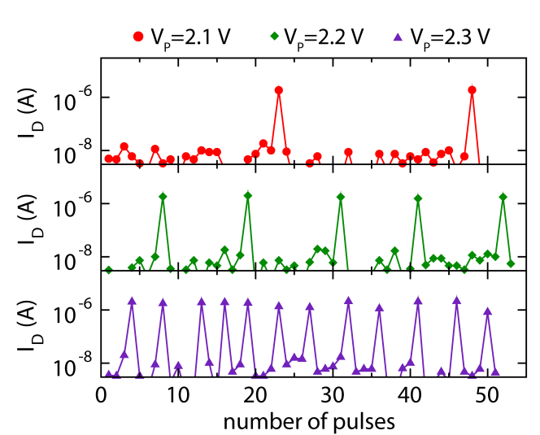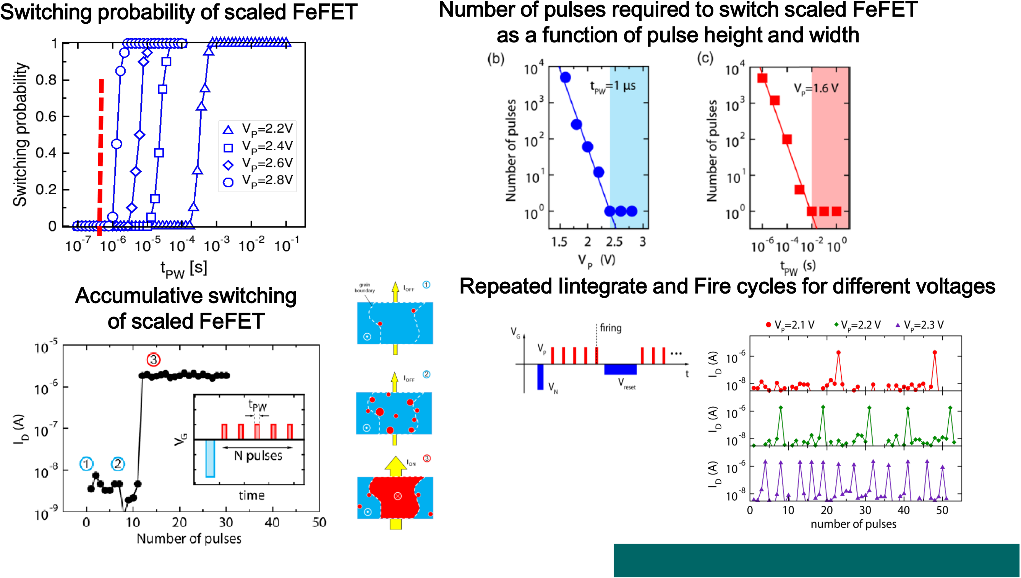

Switching probability of scaled FeFET

Accumulative switching

of scaled FeFET

Number of pulses required to switch scaled FeFET as a function of pulse height and width

Repeated Iintegrate and Fire cycles for different voltages

|  |  |  |
| --- | --- | --- |
| ■ Ultra-scaled FeFETs exhibit accumulative switching | H. Mulaosmanovic et al., ACS AMI 2018 | |
| ■ Probability curve is tunable | H. Mulaosmanovic et al., Nanoscale, 2018 | |
| ■ The effect can be used for mimicking biological neurons | a t u d r e s d e n | c o m p a n y |

Outline

|  |  |
| --- | --- |
| |  | | --- | | Introduction | |

|  |
| --- |
| Ferroelectricity in Hafnium Oxide |

|  |  |
| --- | --- |
| |  | | --- | | Capacitor based Ferroelectric Random Access Memory | |

|  |
| --- |
| Ferroelectric Field Effect Transistor Memory |

|  |  |
| --- | --- |
| |  | | --- | | Ferroelectric Tunnel Junction Memory | |

|  |  |  |  |
| --- | --- | --- | --- |
| |  | | --- | | Negative Capacitance FET | | a t u d r e s d e n | c o m p a n y |

Summary

■ Ferroelectrics are a class of materials that offer unique properties that can be used in nonvolatile memories, NCFETs and other applications Classical ferroelectric materials like PZT, SBT, BFO are extremely challenging to integrate into a semiconductor process   
■ The ferroelectricity in hafnium oxide can solve the integration challenge Ferroelectric random access memories can be much easier scaled using doped hafnium oxide; However: switching voltage and endurance are open issues  
■ Antiferroelectric random access memories could solve the endurance issues   
■ Double layer ferroelectric tunnel junctions show first promising results but need higher read current  
■ The high coercive field of ferroelectric hafnium oxide makes ferroelectric field effect transistors scalable   
■ Ferroelectric field effect transistors can be a replacement of embedded Flash memories and also enable new concept due to their excellent co- integration possibility with standard CMOS devices

|  |  |
| --- | --- |
| a t u d r e s d e n | c o m p a n y |

Thank you

Thanks to all members of the NaMLab and TU Dresden team as well as all cooperation partners for their dedicated work and support!

Parts of this work were financially supported by the European Fund for Regional Development EFRD, the Free State of Saxony, Europe supports Saxony and from DFG.

|  |  |
| --- | --- |
|  |  |

**Thank you for your Attention!**

|  |  |
| --- | --- |
| a t u d r e s d e n | c o m p a n y |

Backup

|  |  |
| --- | --- |
| a t u d r e s d e n | c o m p a n y |